Laboratory work 4
Task 1: Retrieve all airline names in uppercase.
SELECT UPPER(airline_name) AS airline_name_up FROM airlines
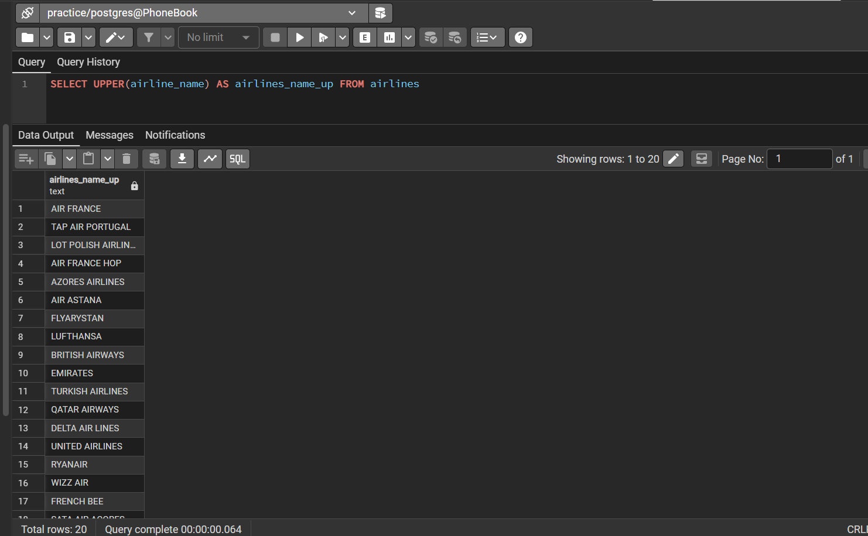
Task 2: Replace any occurrence of the word "Air" in airline names with "Aero".
SELECT REPLACE(airline_name, ‘Air’, ‘Aero’ ) AS updated_name FROM airlines
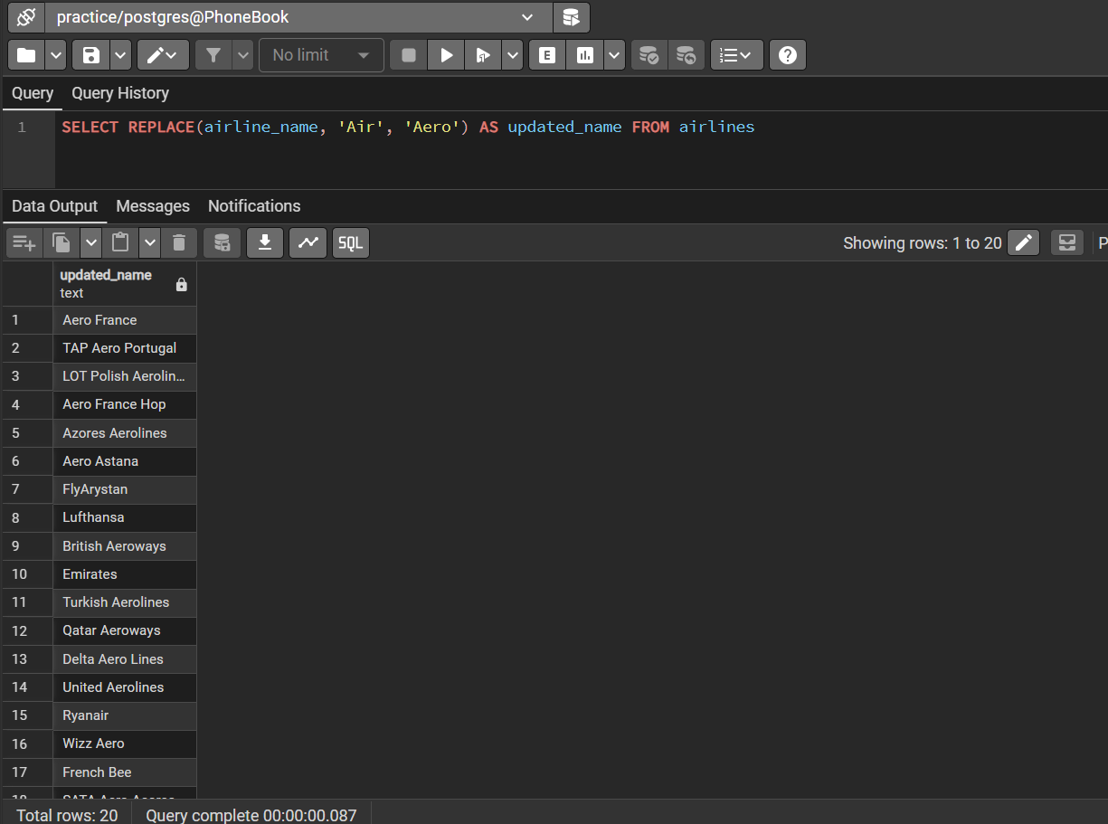
Task 3: Fing all flight numbers that coordinates with both airline 1 and airline 2.
SELECT flight_number FROM flights WHERE airline_id = 1
INTERSECT
SELECT flight_number FROM flights WHERE airline_id = 2
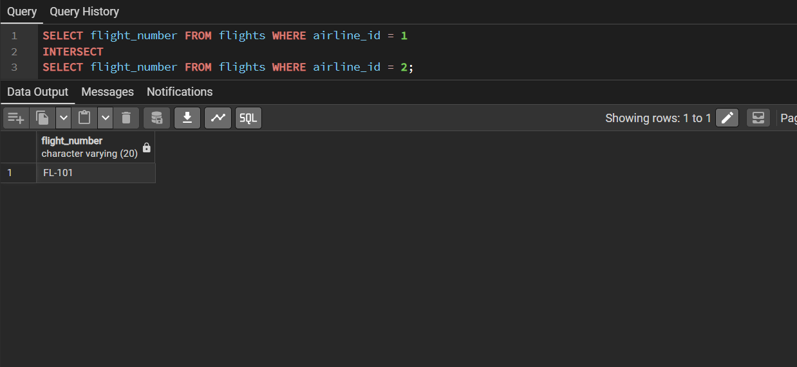
Task 4: Retrieve airports that contain the word "Reginal" and "Air" in their names.
SELECT * FROM airports
WHERE name LIKE '%Regional%' AND name LIKE '%Air%'
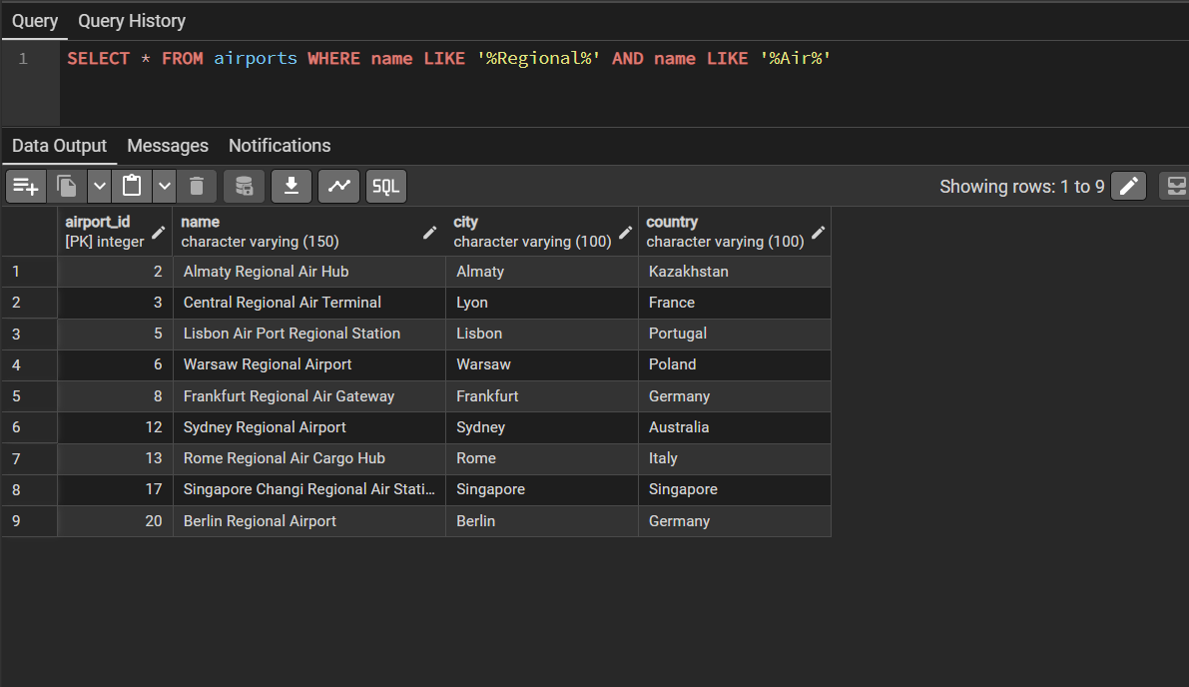

Task 5: Retrieve passenger names and format their birth dates as 'Month DD, YYYY'.
SELECT full_name, TO_CHAR(birth_date, 'FMMonth DD, YYYY') AS formatted_birth_date FROM passengers
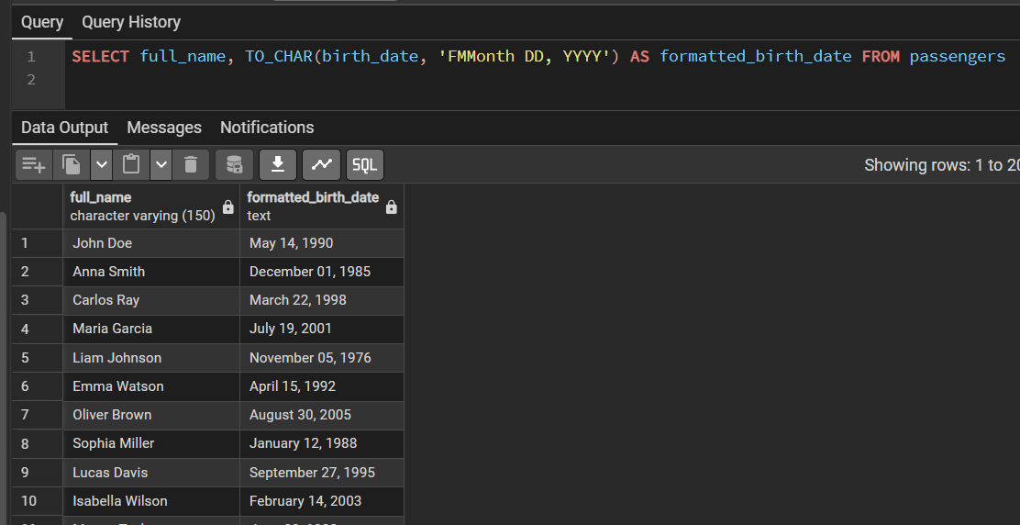

Task 6: Find flight numbers that have been delayed based on the actual arrival time.
SELECT DISTINCT flight_number FROM flights
WHERE actual_arrival > scheduled_arrival
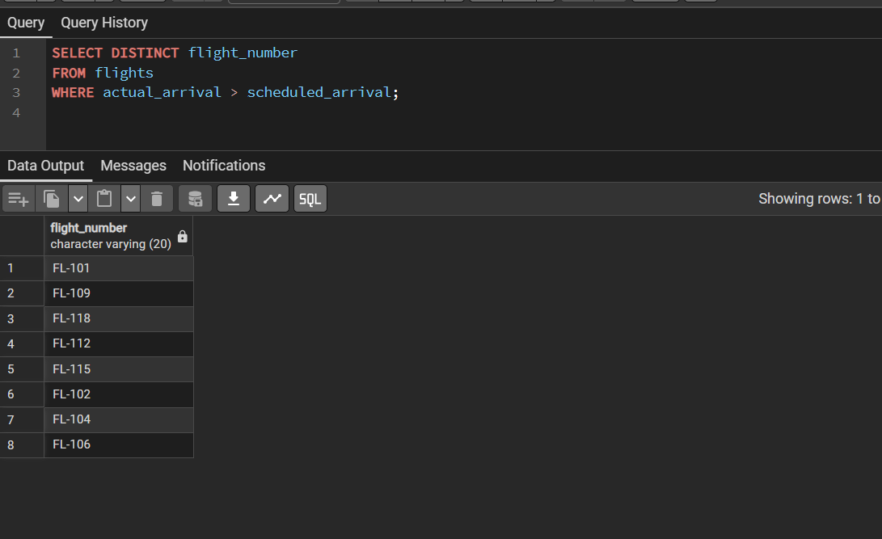
Task 7: Find flights that arrived late according to their actual arrival time compared to the scheduled arrival time.
SELECT * FROM flights
WHERE actual_arrival > scheduled_arrival
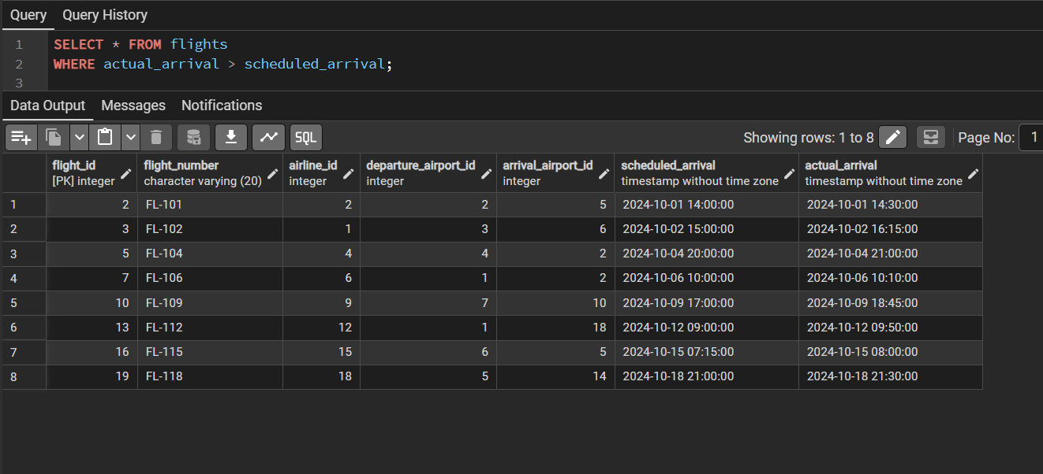

Task 8: Show airlines from any of: ('France','Portugal','Poland') created between '2023-11-01' and '2024-03-31'.
SELECT * FROM airlines
WHERE country IN ('France', 'Portugal', 'Poland') AND created_at BETWEEN '2023-11-01' AND '2024-03-31'
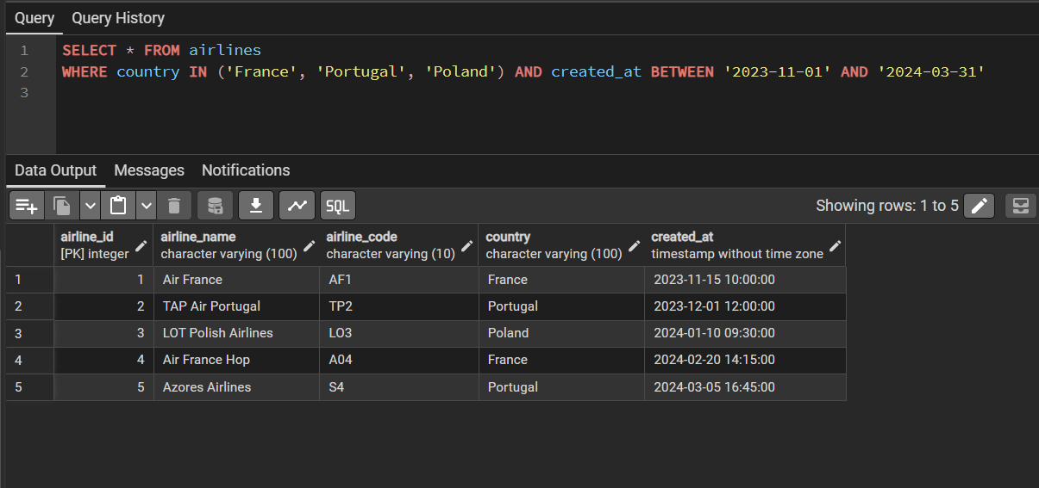

Task 9: Find top3 overweighted baggage with more than 25kg.
SELECT * FROM baggage
WHERE weight > 25 ORDER BY weight DESC LIMIT 3;
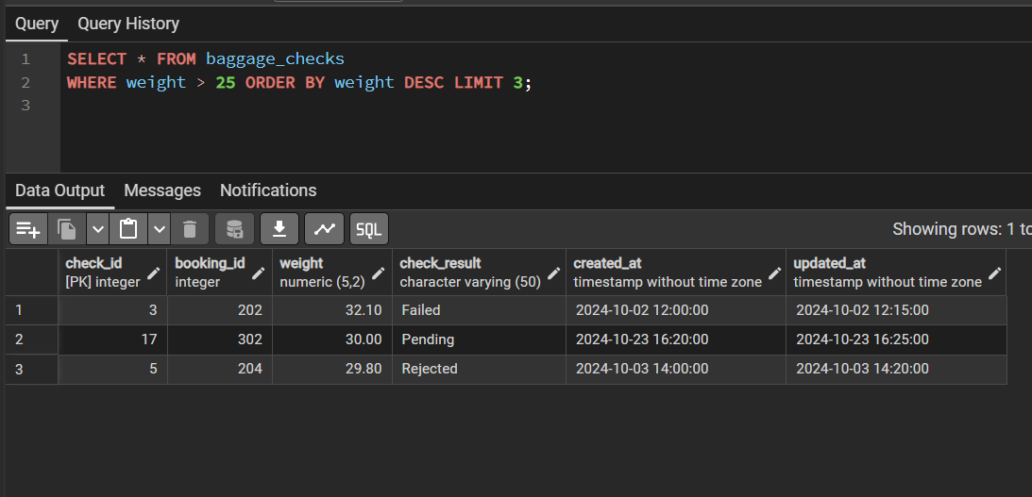
Task 10: Find the youngest passengers’ full name.
SELECT full_name FROM passengers ORDER BY birth_date DESC LIMIT 1;
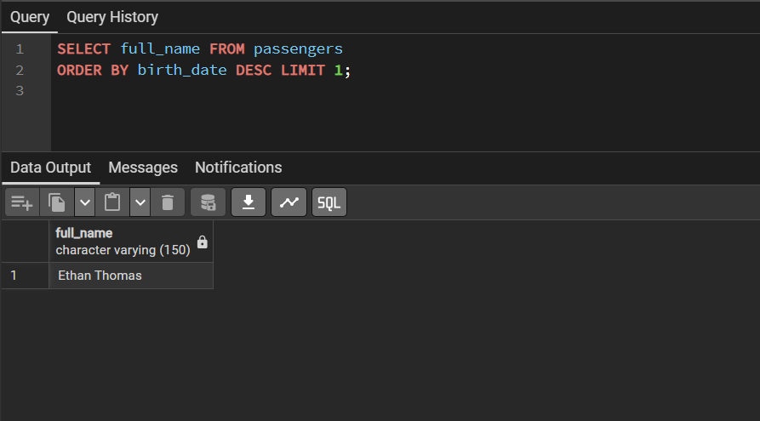

Task 11: Find the cheapest booking price on each booking platform.
SELECT booking_platform, MIN(price) AS cheapest_price FROM bookings
GROUP BY booking_platform;
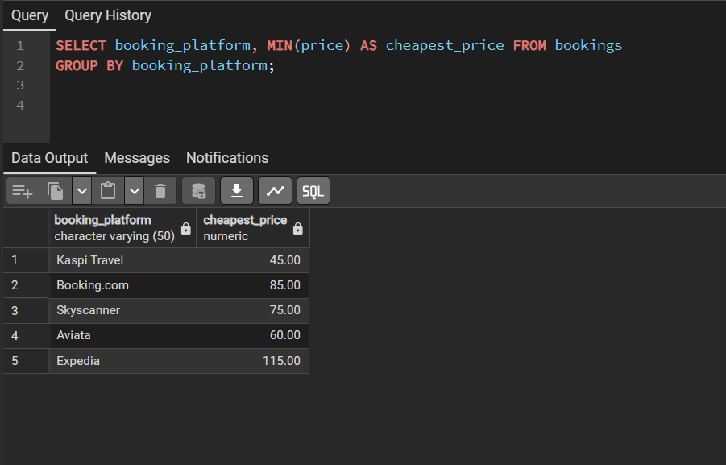
Task 12: Return airlines whose airline_code contains a digit.
SELECT * FROM airlines
WHERE airline_code ~ '[0-9]';
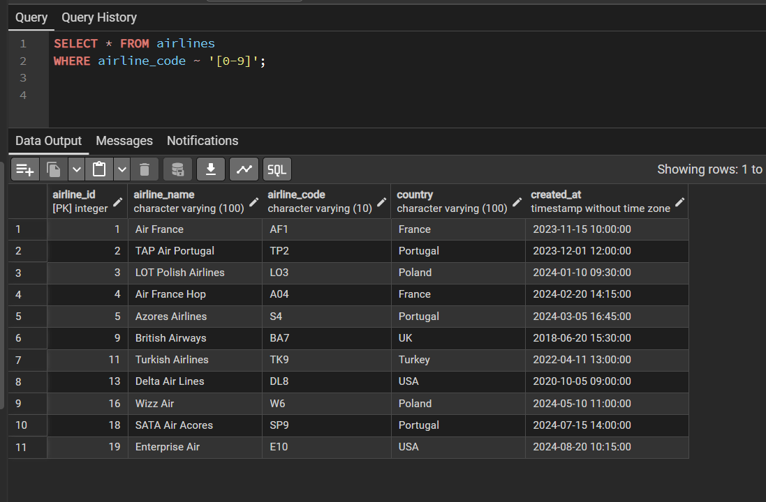
Task 13: List the top5 most recently created airlines.
SELECT * FROM airlines
ORDER BY created_at DESC LIMIT 5
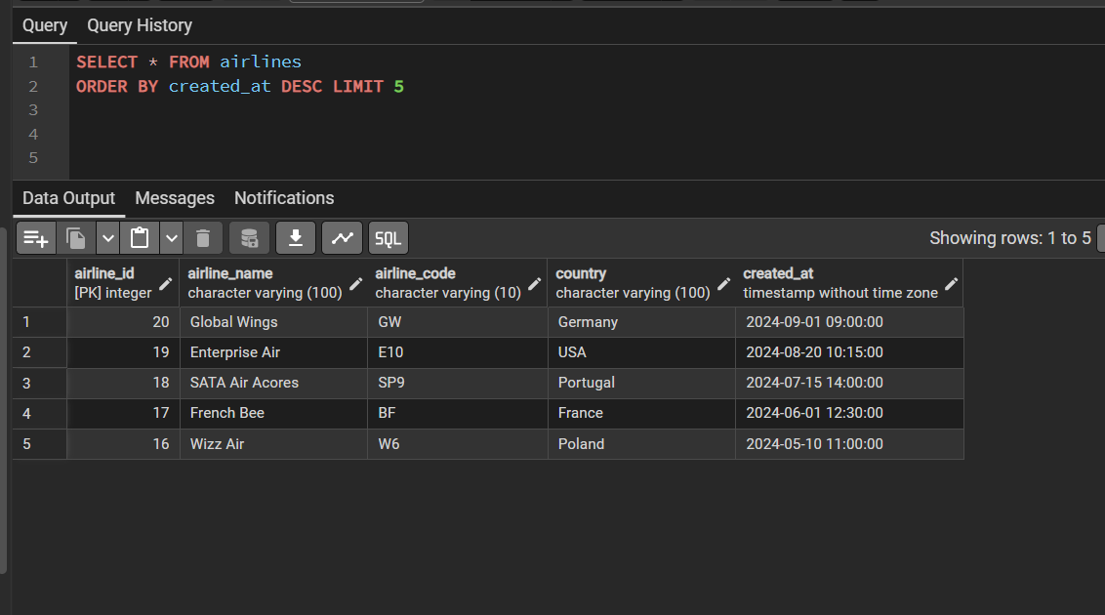
Task 14: Return all rows where booking_id is between 200 and 300 inclusive and check_result <> 'Checked'.
SELECT * FROM baggage_checks
WHERE booking_id BETWEEN 200 AND 300 AND check_result <> 'Checked';
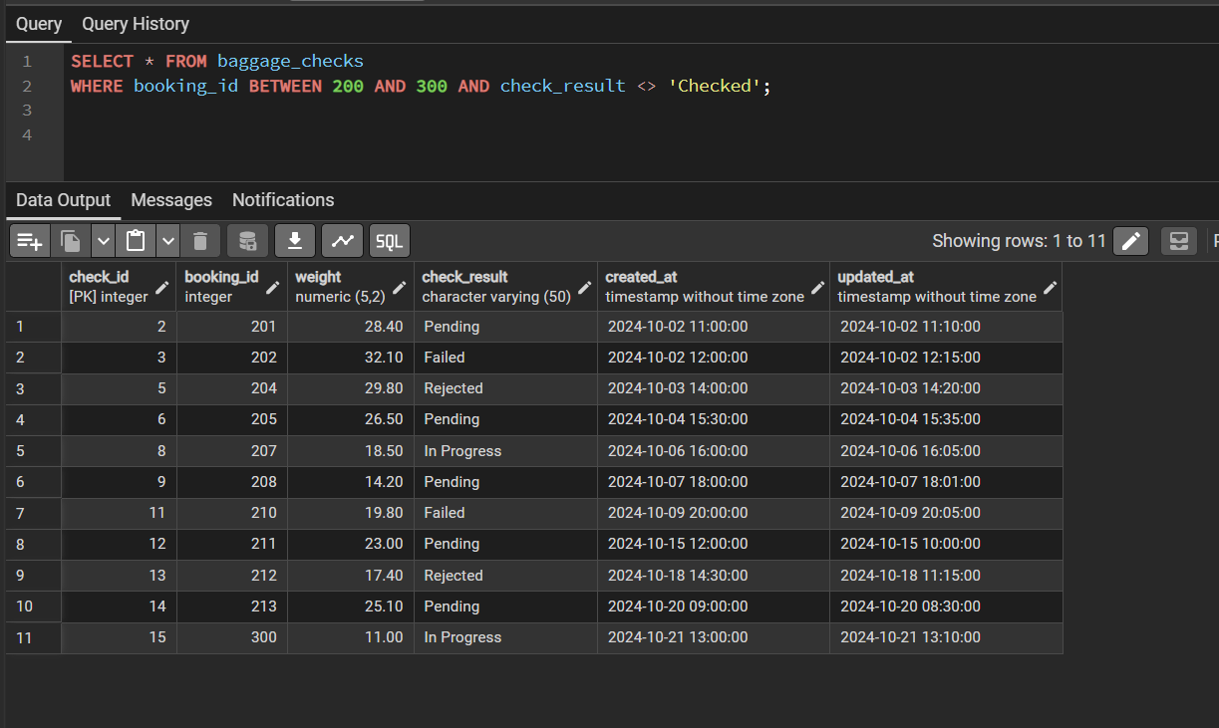
Task 15: Baggage checks where update_at is in the same month as created_at but occurs earlier than created_at.
SELECT * FROM baggage_checks
WHERE updated_at < created_at AND DATE_TRUNC('month', updated_at) = DATE_TRUNC('month', created_at);
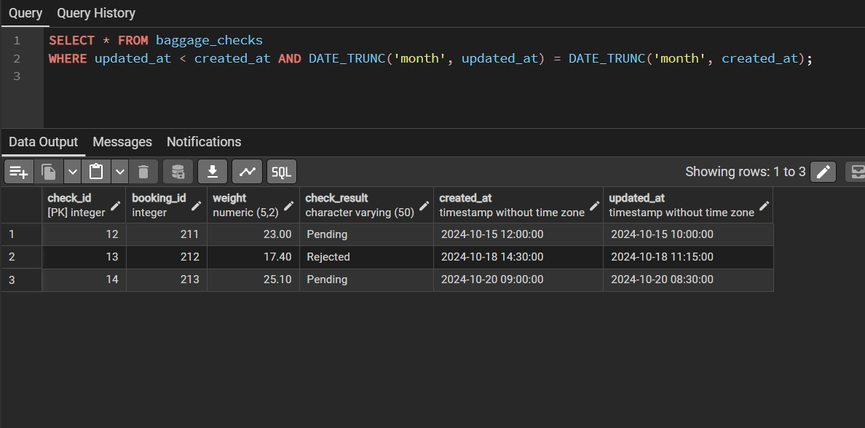

Overall:
In this lab we worked with data retrieving SELECT statement, covering various filtering, grouping, sorting. Through various requests, lab covers pattern matching, date formating, flitering with conditions, grouping with additional functions and sorting across different tables.

